**Github Project Activity**

**20K-0409 Mukand**

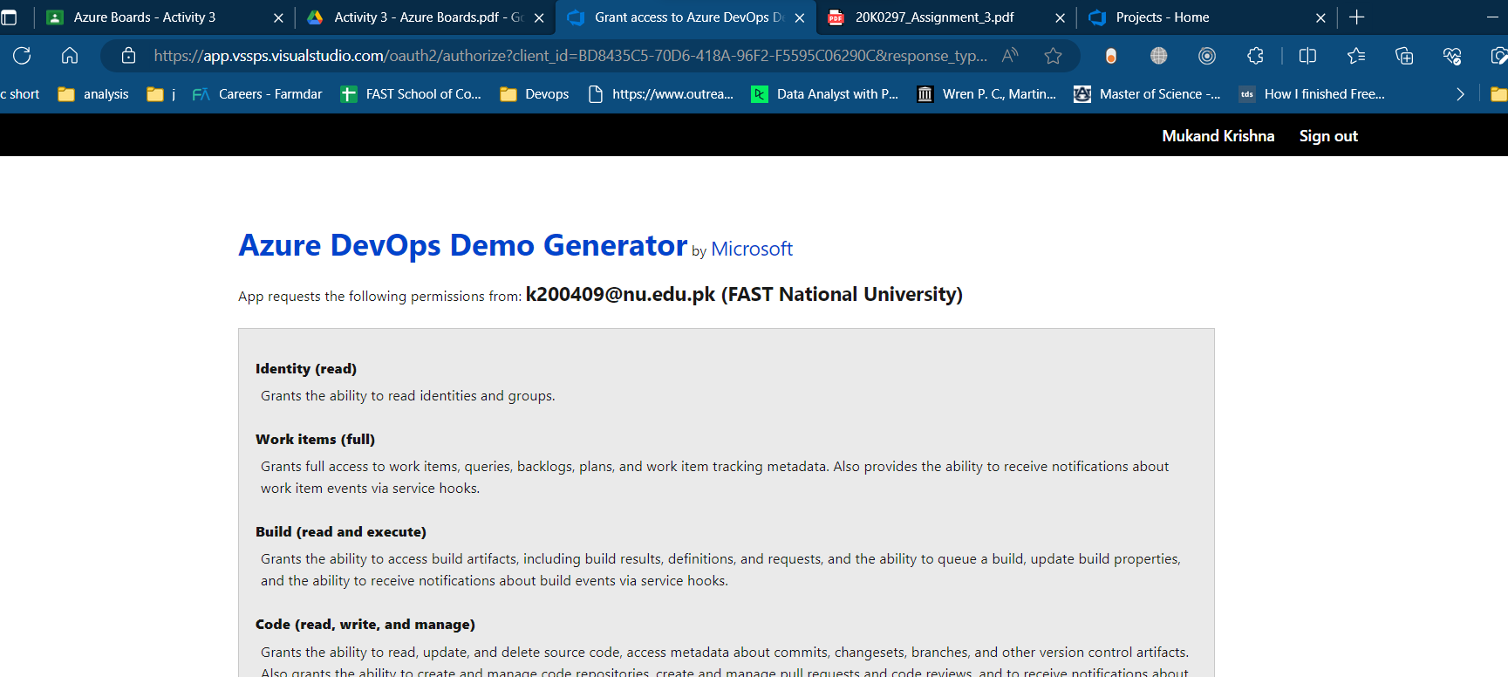**Exercise 0: Configure the lab prerequisites:**

**Exercise 1: Manage Agile project:**

**PUL-WEB**

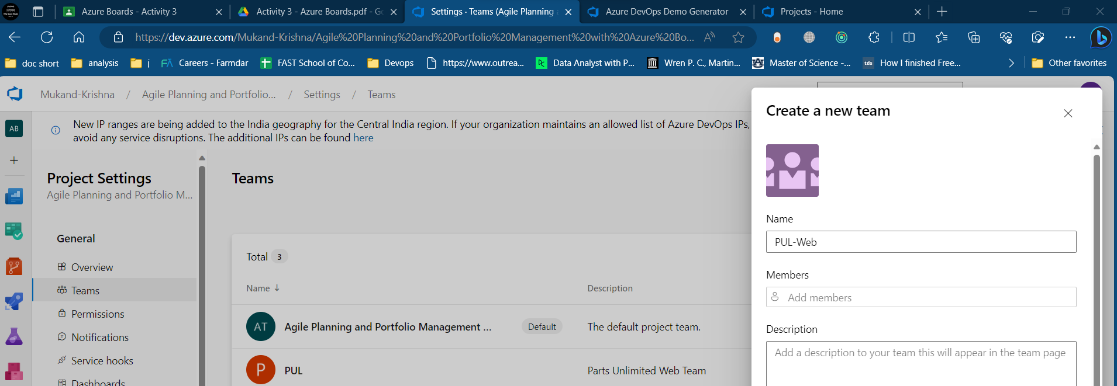

**Iterations:**

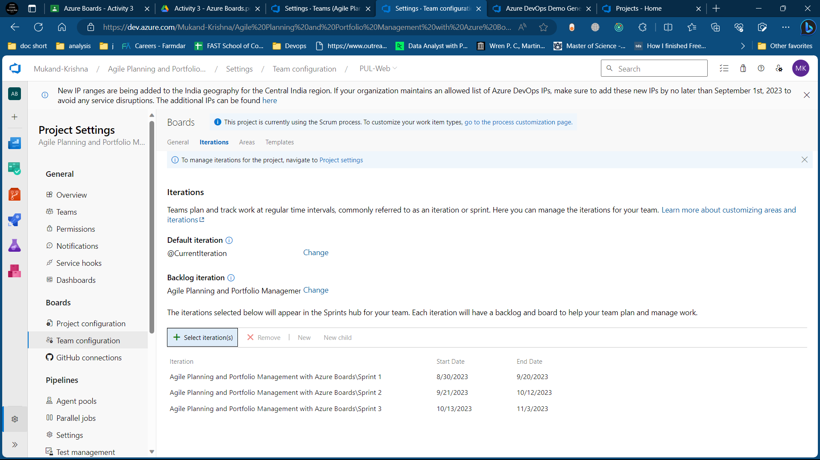

**Task 2: Manage work items:**

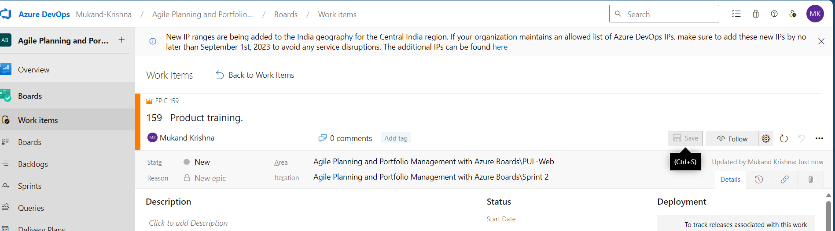

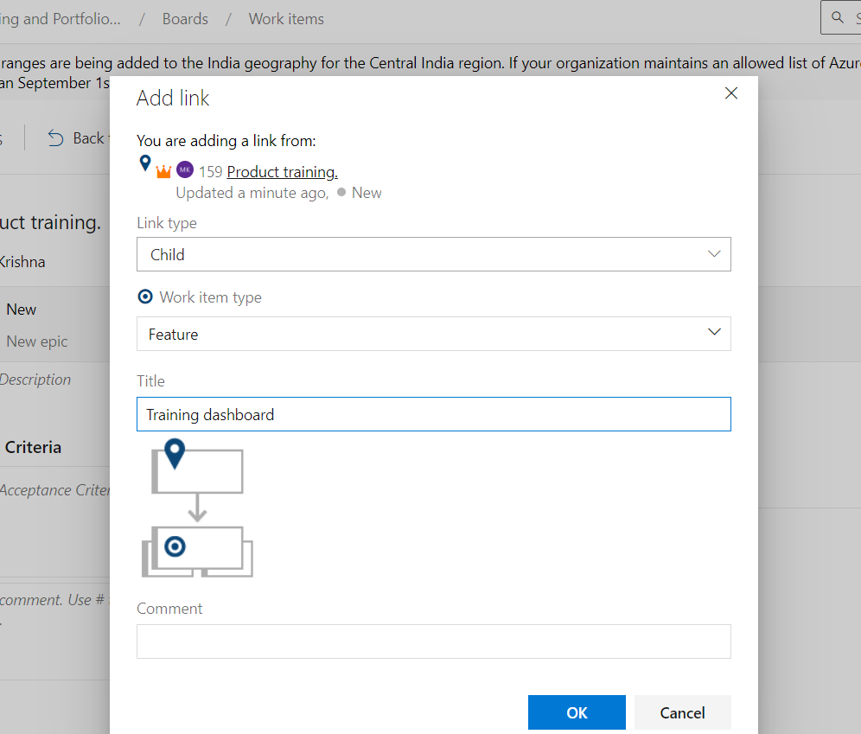

**Backlog items: 16, 17.**

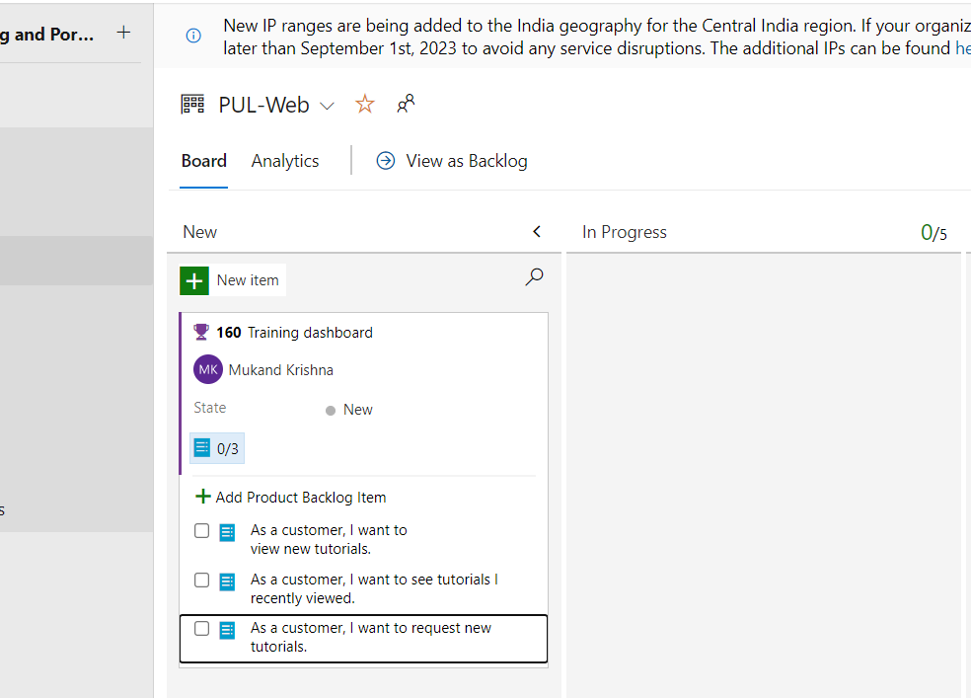

**28, 29:**

**30:**

**Task 3: Manage sprints and capacity:**

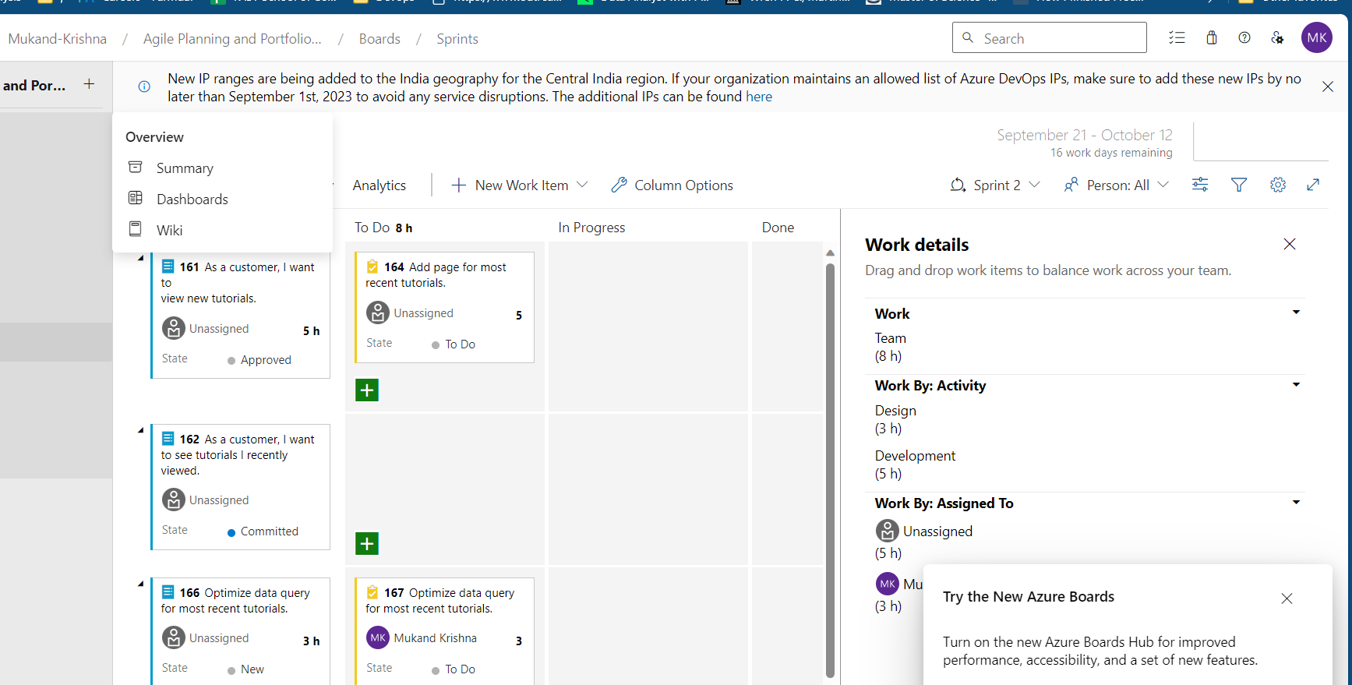

**Configure team settings:**

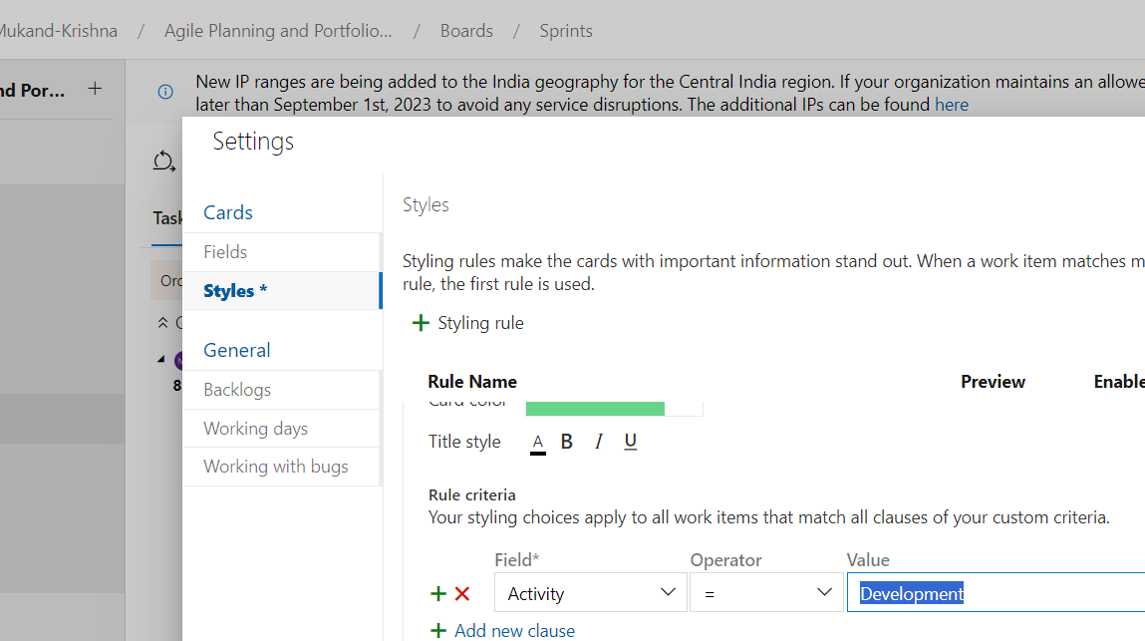

**Task 4: Customize Kanban boards:**

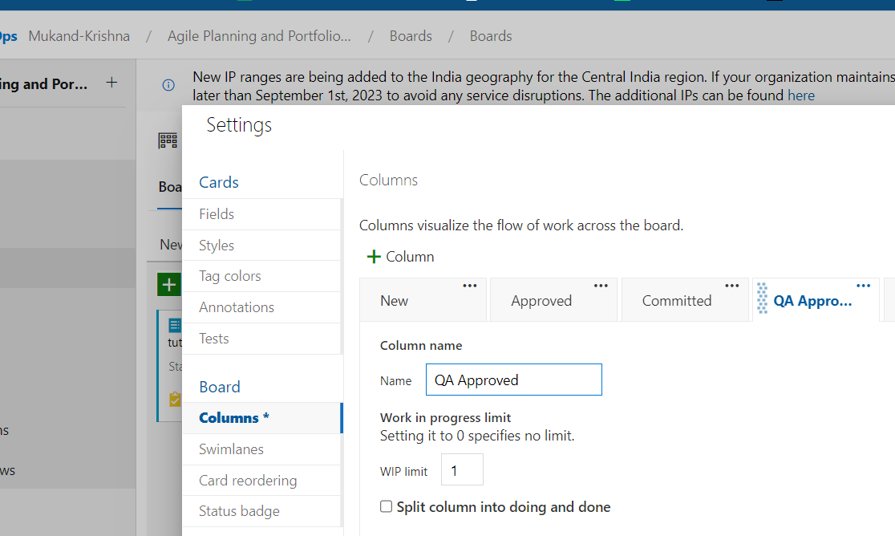

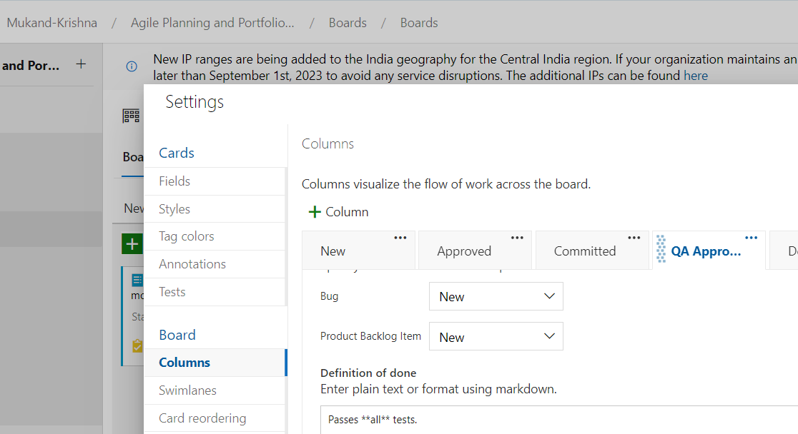

**SwimLane:**

**Task 5: Customize team process:**

**Creating Process:**

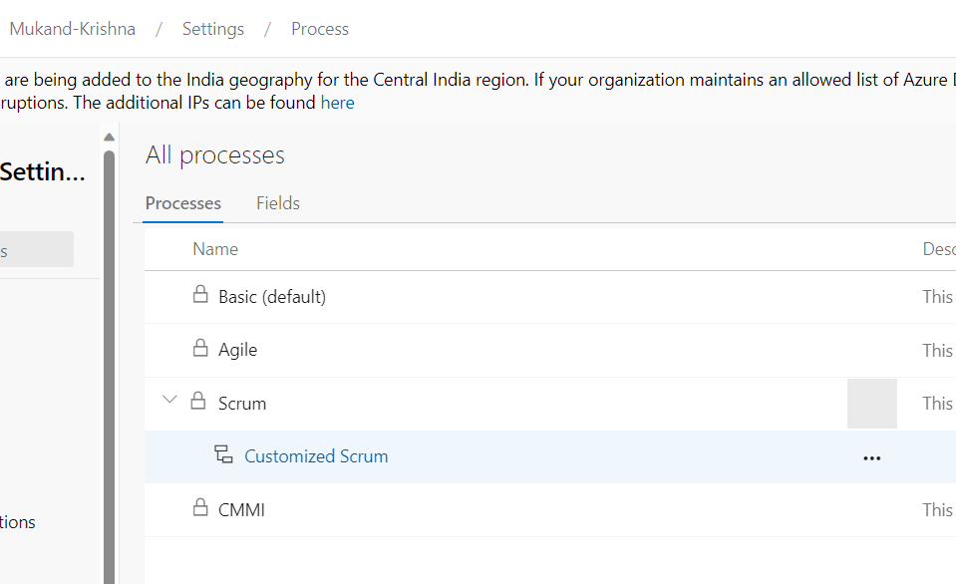

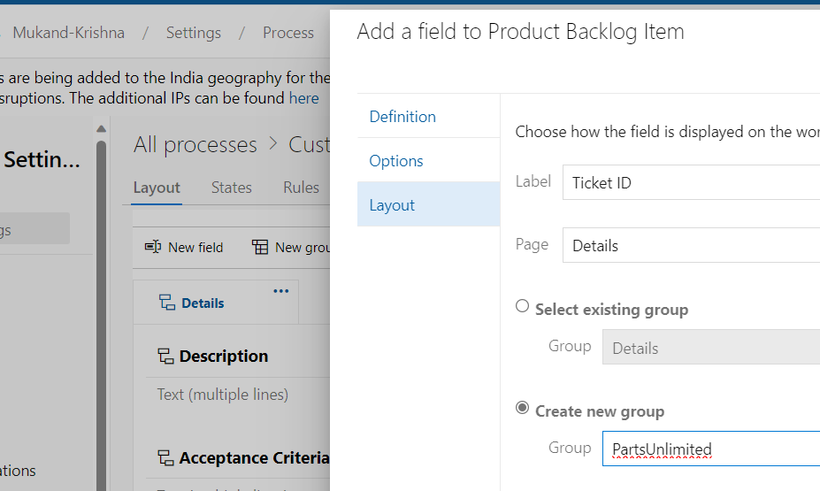

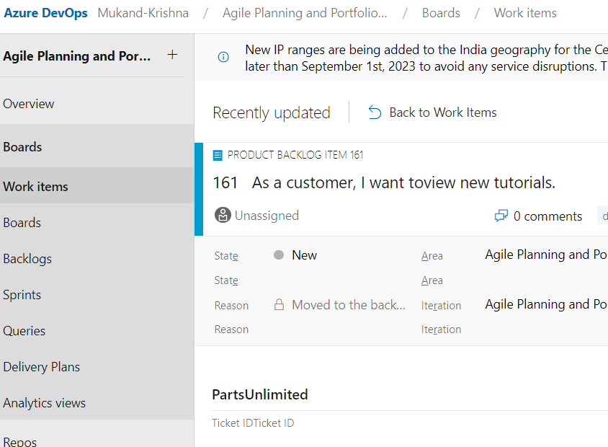

**Exercise 2 (optional) : Define dashboards:**



